**Business Analytics using Python & Excel**

Business Analytics with the Retail Sales Dataset analyzing using Python & Excel. This project is mainly focused on the Objective of the following targeted categories using Frameworks like pandas, plotly and Excel Workbook, so they are as follows,

* Sales Performance
* Customer Behavior
* Product Analysis
* Segmentation & Targeting

Using these four Analytics the **Actionable Recommendations** are provided increase the Profit in the Retail Business.

**Libraries needed:-**

**Pandas & Plotly**

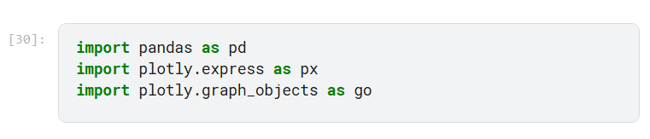

**Load Dataset**

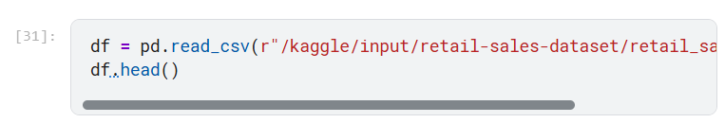

**The Above data is now ready to go for an Analysis.**

Let’s Deep Dive into the process to know more about Business Analytics and to know how Business Analytics works with Pandas and Excel. The step-by-step process is explained below.

**Firstly**, Let’s See about the Sales Performance,

**Sales Performance**

1. What is the total revenue generated over a specific period (e.g., monthly, quarterly)?

**Plotly**

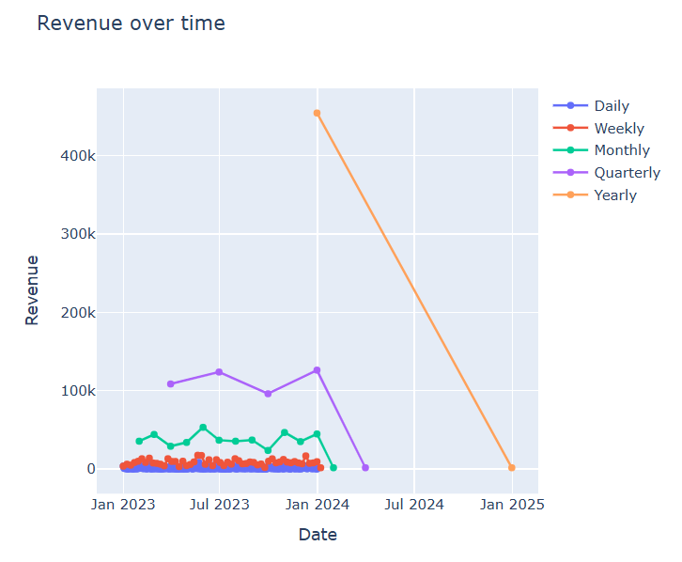

**2.***Which product category generates the highest revenue?*

**Pandas & Plotly**

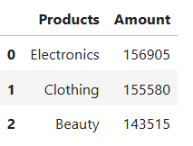

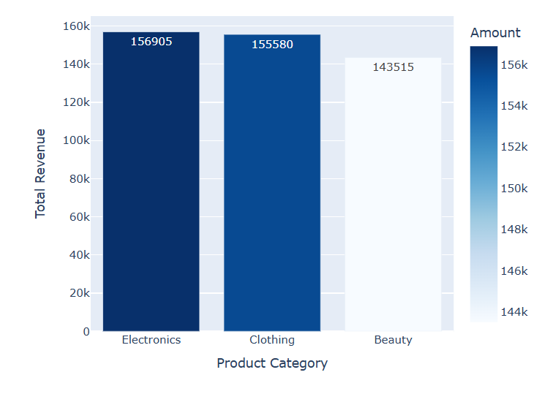

***3.****What are the top-selling products by quantity sold?*

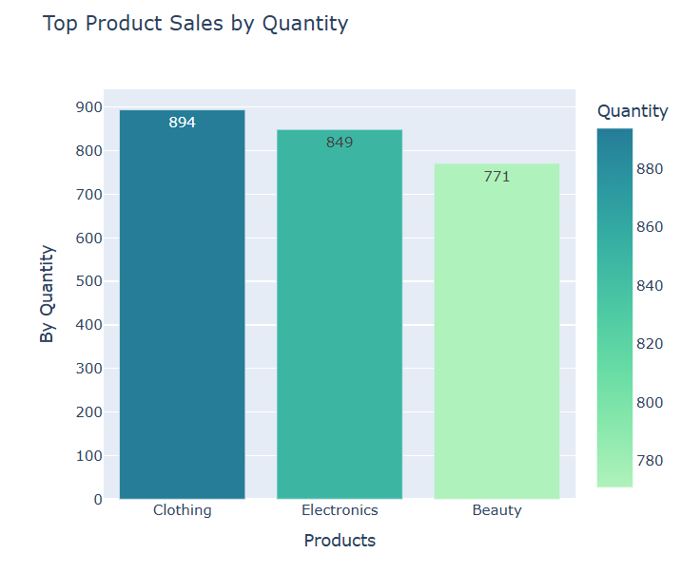

***4.****How has the total amount of transactions changed over time?*

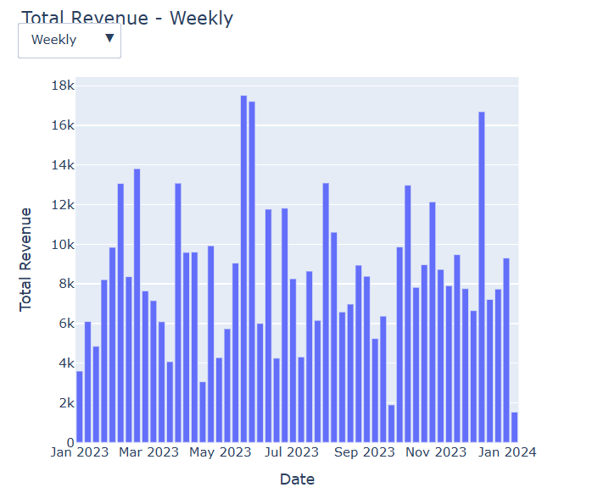

The above drop-down is used to change the Options like Weekly, Monthly, Daily, Quarterly and Yearly Revenue over Time.

**Excel**

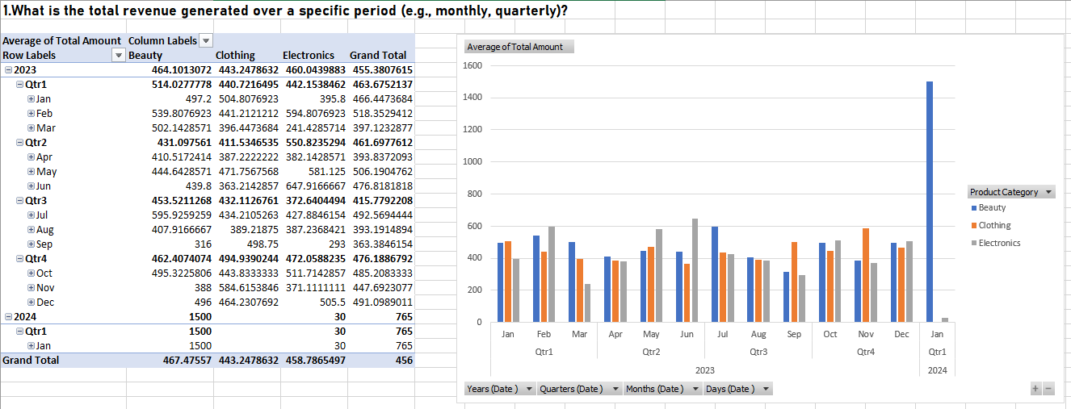

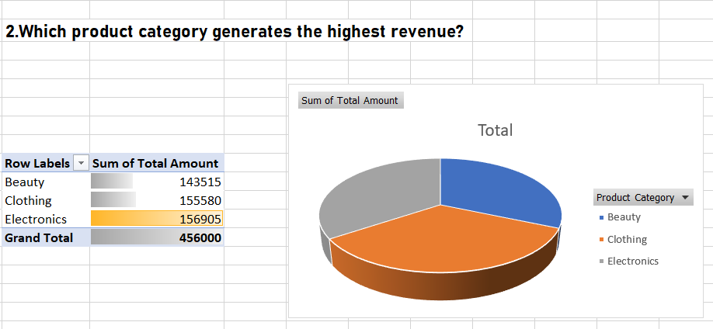

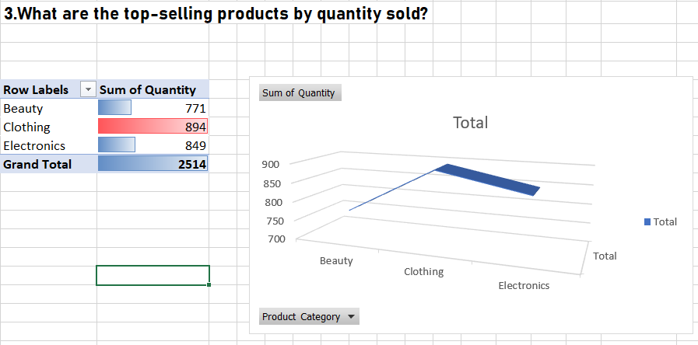

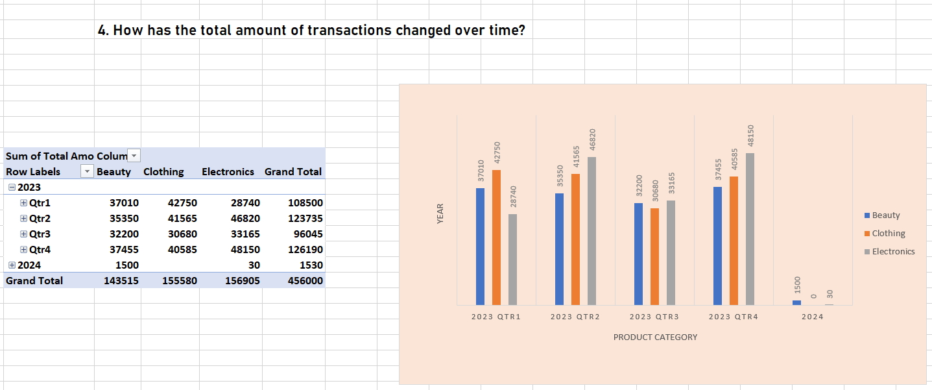

**Secondly**, Let’s See about the Customer Behavior that is how the customers behaves at the time of Purchase and to notice some Trends like Gender & Age Group.

**Customer Behavior**

***Using Plotly***

1. *How does purchasing behavior differ between genders?*

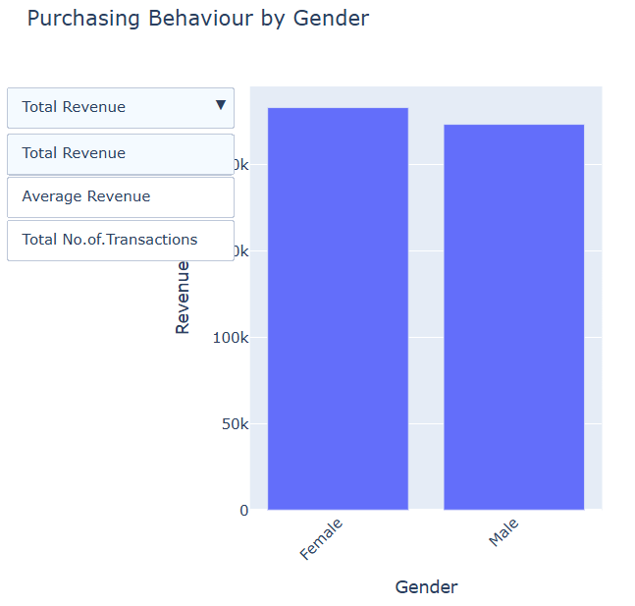

***2.****Which age group contributes the most to total sales?*

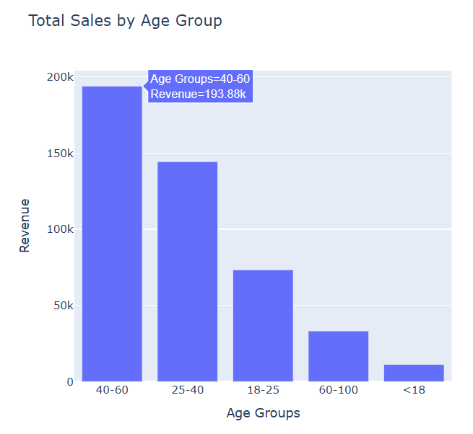

***3.****What is the average age of customers, and how does it vary by product category?*

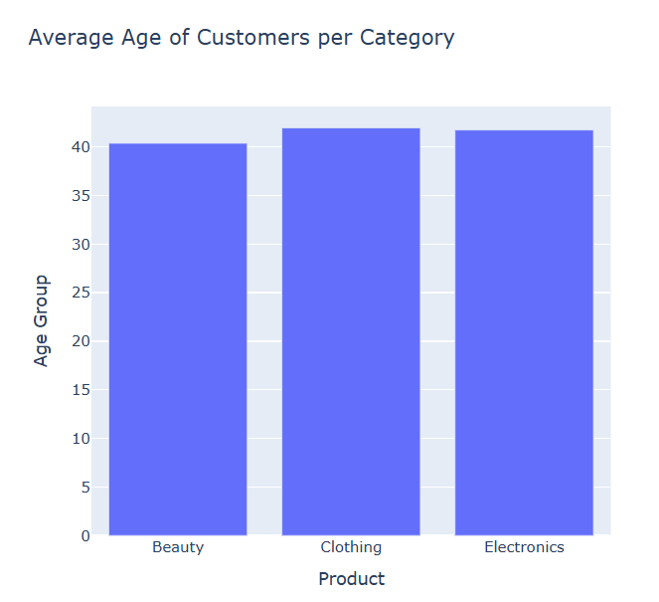

***4.****Are there any trends in purchase frequency by gender or age?*

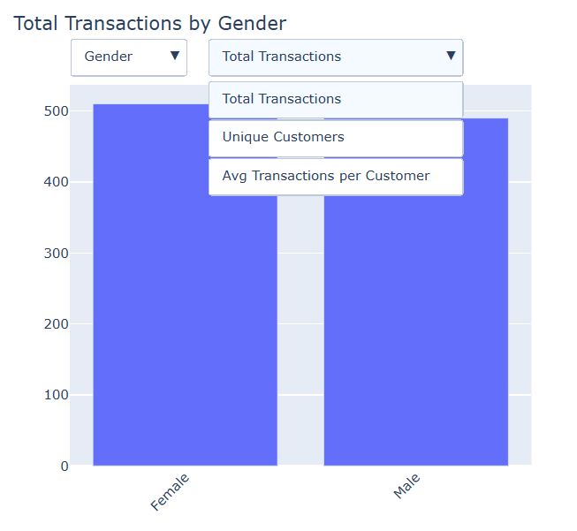

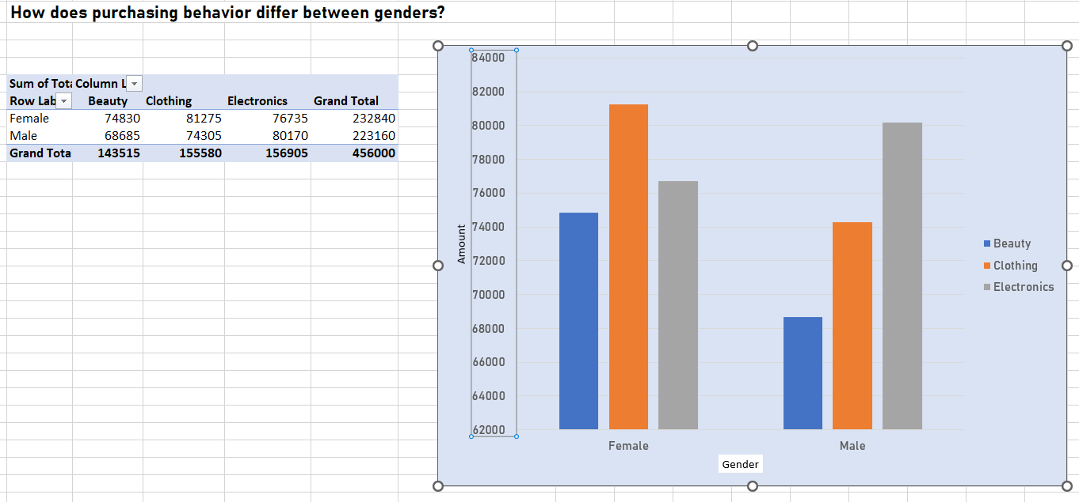***Using Excel,***

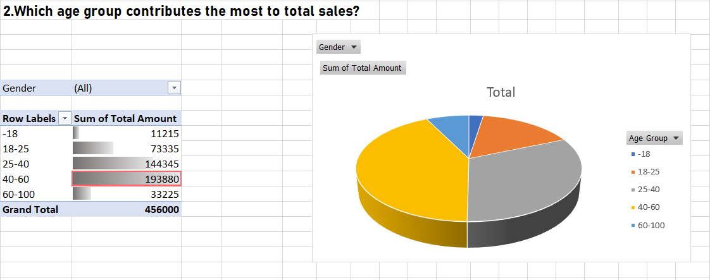

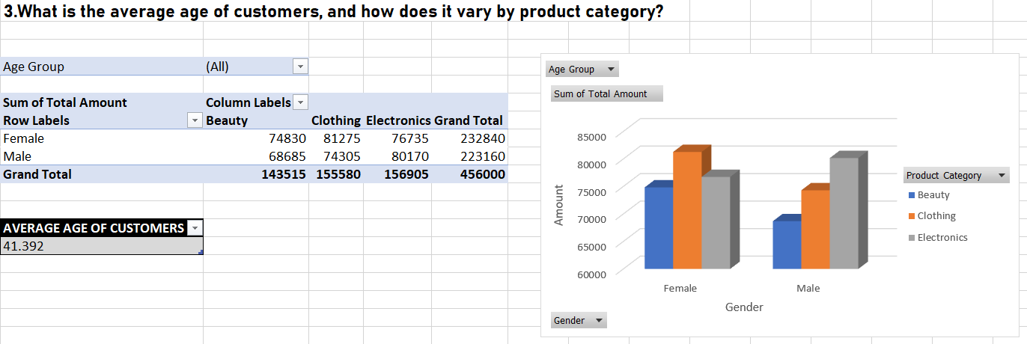

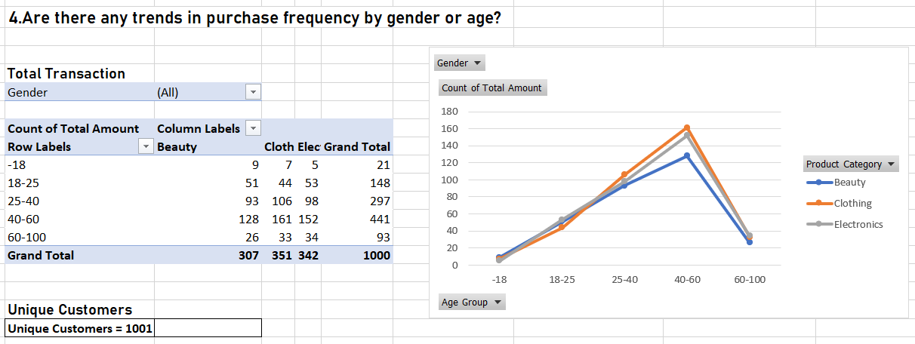

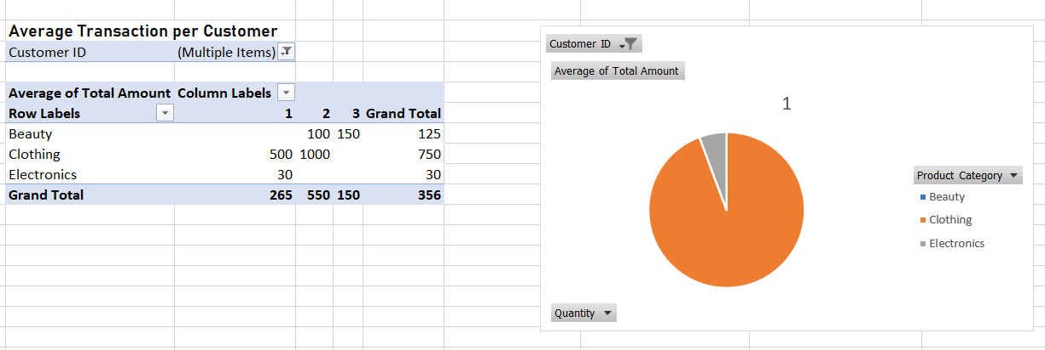

**Thirdly**, Let’s See about the Product Analysis, To analyse the Product Category like Clothing, Electronics and Beauty in detail.

**Product Analysis**

***Plotly,***

***1.****Which product category has the highest average price per unit?*

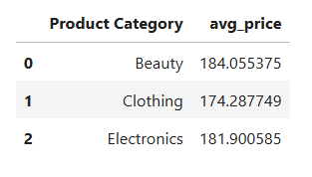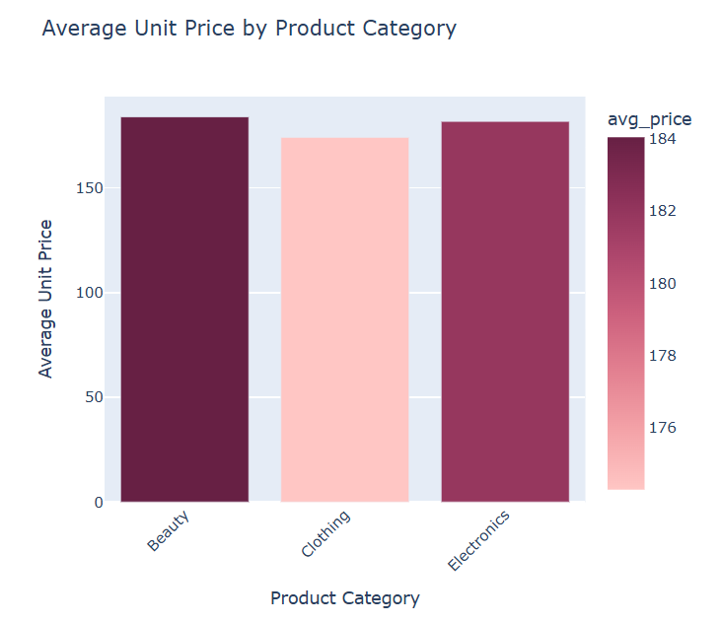

***2.****How does the quantity sold vary across different product categories*

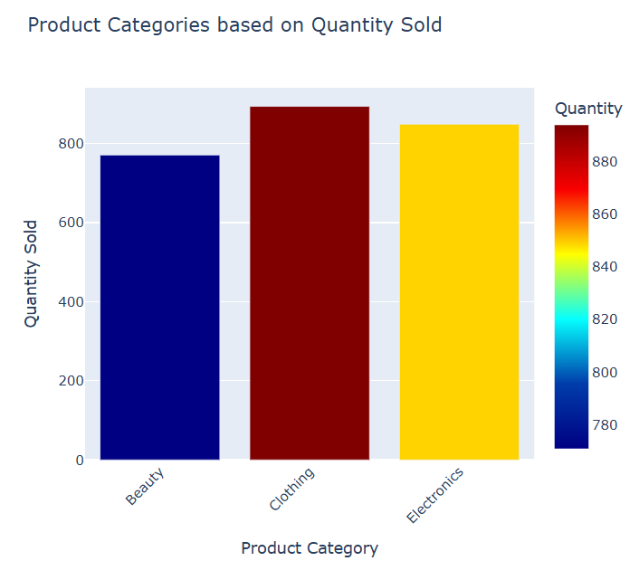

***3.****Are there any product categories with unusually high or low total amounts?*

*No unusuals detected as the Z-Score is between -1 to +1*

***Code***

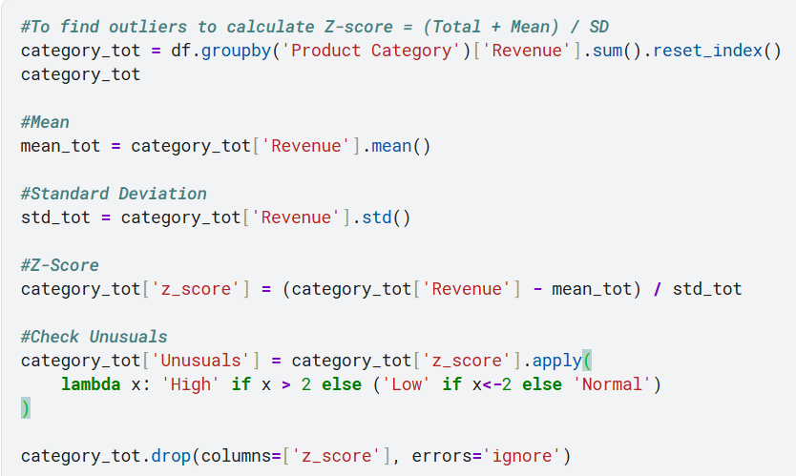

***Pandas***

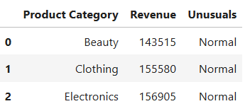

***Excel***

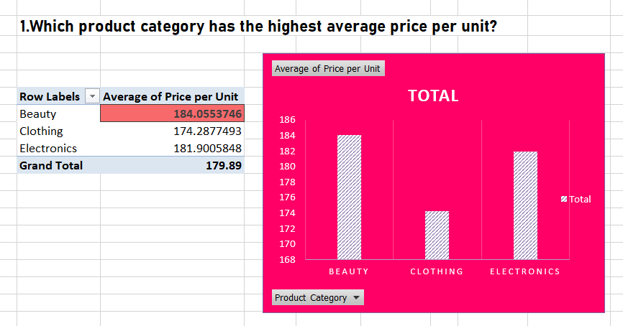

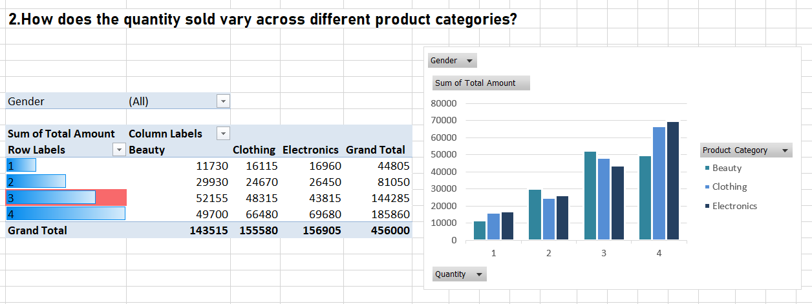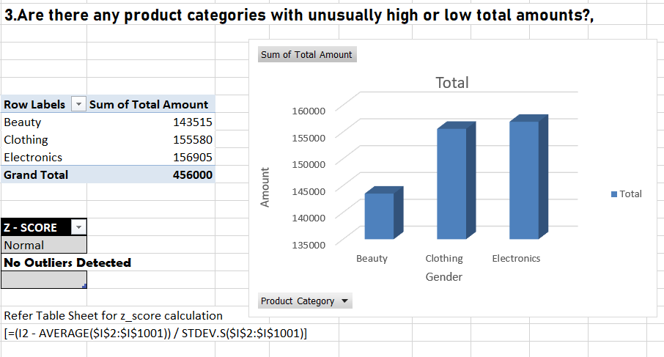

**Fourly**, Let’s See about the Segmentation & Targeting, This involves Segmenting the Column Names according to our analysis and targeting on specific Trends for growth of the Business.

**Segmentation & Targeting**

***Plotly,***

***1.****Which combination of gender and age group buys the most expensive products?*

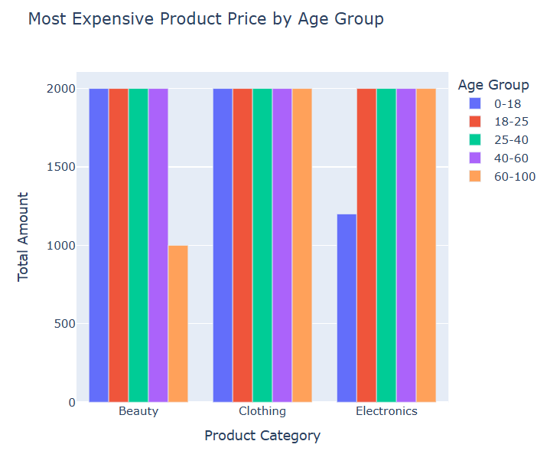

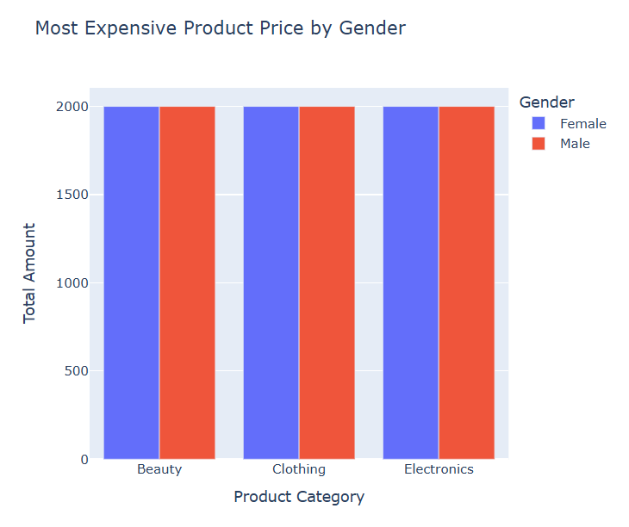

The above tells us Both the Male and Female brought Expensive Gift

***2.****Are there specific product categories preferred by certain demographic segments?*

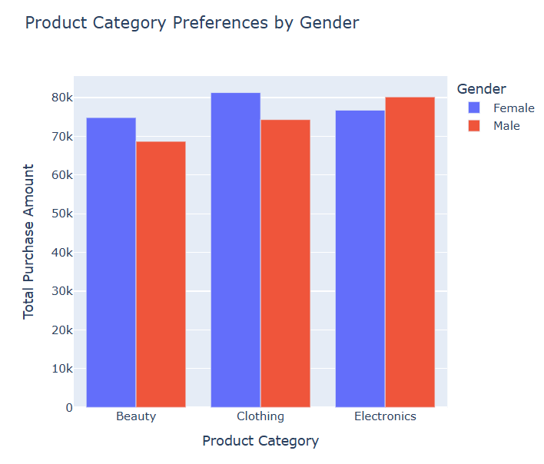

*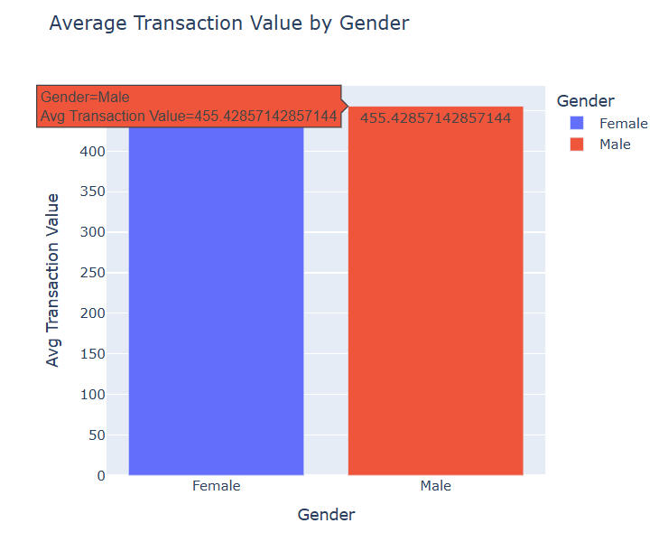****3.****What is the average transaction value per customer segment (e.g., by gender or age range)?*

***Excel,***

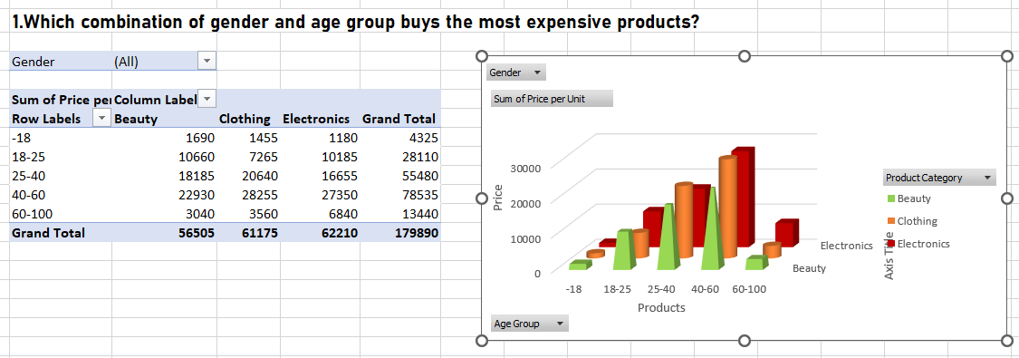

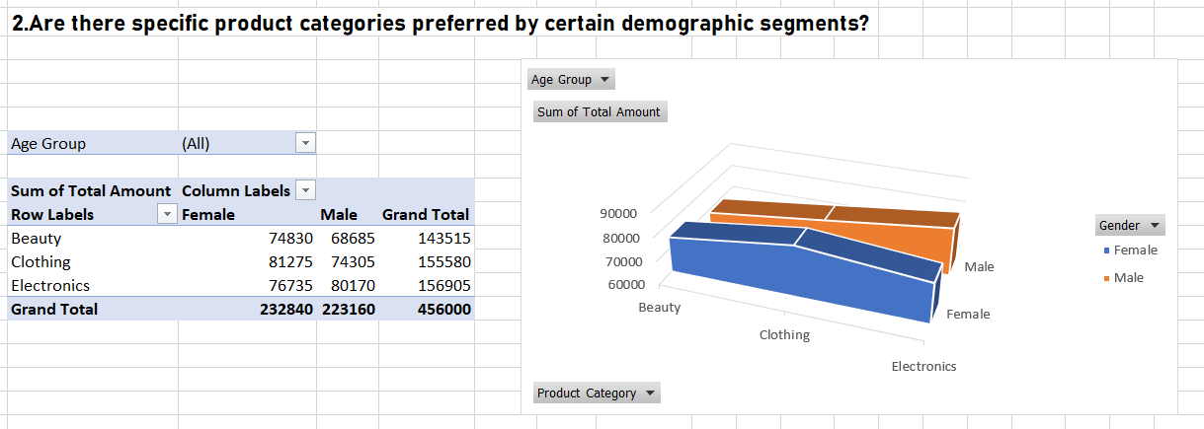

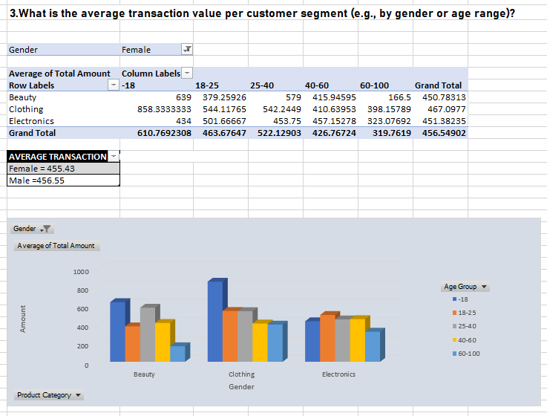

Therefore these are the four steps of analyses that are done by using ***Retail Sales Dataset*** and the helpful insights that we get from the analyses helps us Scale-up, Up-skill and Improve the Business or a particular organization. The Insights that we get from analyzing the dataset is very important and helps us to solve many Business Problems. The key note comes here by asking questions about Businesses, Why Customer Sales is very low? Why the particular product is dropping? And What Recommendations can be provided to increase the sales that profits the company? Let us see the final recommendations by the analyzed results that answers for many question in the business and solve many problems in Business Analytics, Python Libraries like Pandas and Plotly helps us to analyze and visualize data more efficiently and Excel plays a main role for a Quick and Easy analytics for Business.

Let us Deep Dive by Recommending some solutions by providing answer for the questions that are being asked in each analysis.

**Answers that are provided by each analysis:**

**Sales Performance**

**1.What is the total revenue generated over a specific period (e.g., monthly, quarterly)?**

Total Revenue generated over a period of time:

Daily Revenue - 1000-2000

Weekly Revenue - 7000-9000

Monthly Revenue -30.00k-50.00k

Yearly Revenue -100.5k-130.20k

**2.Which product category generates the highest revenue?**

The product category that generates highest revenue is ***Electronics*** & secondly Clothing

**3.What is the top-selling products by quantity sold?**

***Clothing*** is the top-selling product in Quantities

**4.How has the total amount of transactions changed over time?**

Monthly Highest Sales is ***May***, secondly October, thirdly December and February and the Last is September.

**Customer Behavior**

**1.How does purchasing behavior differ between genders?**

***Female Customers*** are increased compared to Male in all (Average Revenue, Total Revenue, Total No. of Transactions)

**2.Which age group contributes the most to total sales?**

The Age Group that contributes the most to total sales is ***40-60***

**3.What is the average age of customers, and how does it vary by product category?**

The average age of customers is ***40***, Their top purchases is ***Clothing.***

**4.Are there any trends in purchase frequency by gender or age?**

Gender-vise ***Female*** customers are high and Age-vise ***40-60*** age group is high (Unique Customers, Total Transaction, Average Transactions per Customer)

**Product Analysis**

**1.Which product category has the highest average price per unit?**

***Beauty*** Product has the highest average per unit.

**2.How does the quantity sold vary across different product categories?**

***Clothing*** is the Highly sold product in Quantities & ***Beauty*** is the Least Sold product in quantities.

**3.Are there any product categories with unusually high or low total amounts?**

***No Unusual high or low amount***, all tends to be normal (z-score meets -1 to +1).

**Segmentation and Targeting**

**1.Which combination of gender and age group buys the most expensive products?**

* 1. ***All Age Groups buy expensive products***, But ***60-100 shows low interest in******Beauty*** *and* ***0-18 in Electronics.***
  2. ***All Gender shows equal interest*** on buying the expensive products.

**2.Are there specific product categories preferred by certain demographic segments?**

***Female*** show more interest in ***Clothing*** and Less interest in Beauty

***Male*** show more interest in ***Electronics*** and less interest in Beauty

(total_purchase_amount)

**3.What is the average transaction value per customer segment**

**(e.g., by gender or age range)?**

***Average Transaction value per Customer Segment:***

***\* Female = 456.55***

***\* Male = 455.43***

***Therefore, these are the Analytics done by the Retail Sales Dataset. This Answers provide the most valuable and useful insights to change the Marketing campaign and Other things, The KEY of this Quick Summary of this analysis is,***

1. ***Firstly, start with understanding the Retail Sales Dataset, Understanding the Column Names, whether it is a category, numerical or string***
2. ***Asking Questions for the Dataset like What? Why? When? and how? questions***
3. ***Secondly Choosing the right platform to analyze data like Excel, Pandas and Plotly(to visualize).***
4. ***Find Answers for these questions using the platform that you have chose to analyze data with...***
5. ***Research on that answer to find the best recommendations ideas***
6. ***Convert the Ideas to Visualization.***

***Now let’s deep dive into provide Actionable Recommendation to improve the Sales, Customer, Marketing Campaign etc..***

**Actionable Recommendations**

**Which product categories should be promoted based on sales performance?**

Beauty products

**Are there opportunities to adjust pricing for underperforming categories?**

Yes, Beauty Products & Male

**Should marketing campaigns target specific age groups or genders based on purchase trends?**

Yes, 0-18 age = Electronics and 40-60 age = skincare(Beauty), Marketing campaigns should target male customers.